EARLY CHILDHOOD EDUCATION AND CARE SERVICES
HUBWORKS – UNDERSTANDING FAMILY INVOICES

For some families, understanding the parent invoice can be confusing. To help you we have provided an example below and included some explanations over the following pages of the specific sections. If you encounter any issues with your invoice or would like to speak with someone in person to help you understand it better, please contact our Finance and Administration Officer on 5943 7814.

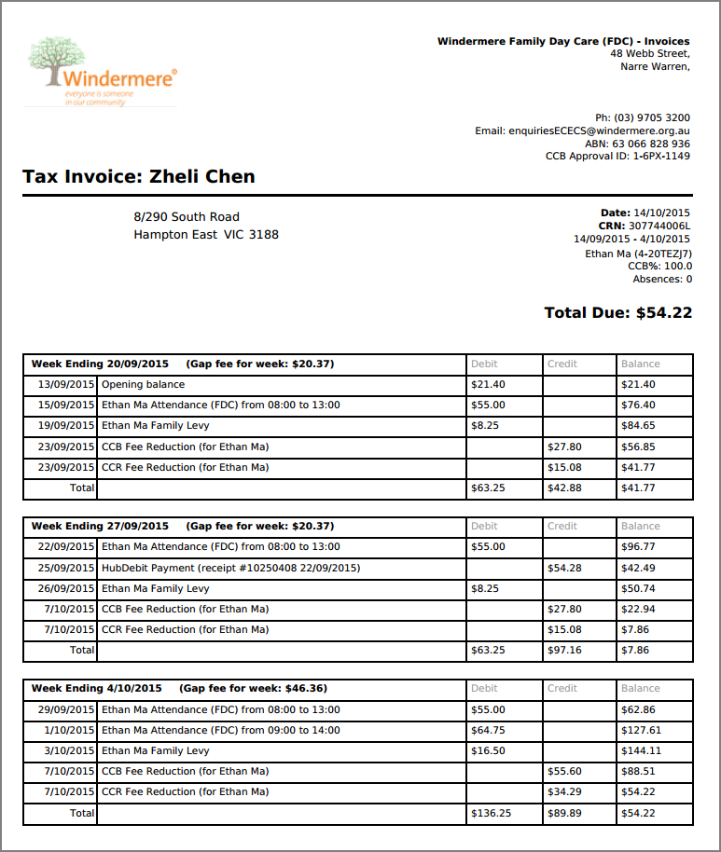

Address appears here

Parent Name appears here
c
c
c
c
c
c
c
c
c
c

YOUR INDIVIDUAL DETAILS
The top section of the invoice includes the parent name, address and details of the child or children (if there are multiple children from the same family in care).

The CRN is your child’s customer reference number provided by Centrelink.
The date listed under the CRN is the date range that your invoice is for.

The line underneath the date includes your child’s name and their enrolment ID.

The CCB % is the Child Care Benefit percentage provided by Centrelink that your child/children is entitled to, and relevant on the date the invoice was issued. Centrelink do not notify us if they change your CCB percentage so please take note of this each time you receive your invoice and if your CCB pecentage changes unexpectedly, please contact Centrelink immediately.

Children are entitled to 42 absence days per year where CCB is still applied. Your invoice will show you a running total of the absences used for each child so you can keep track.

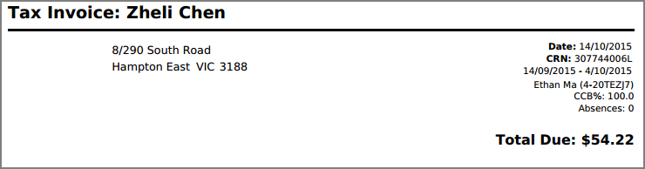
Parent Name
Parent Address

THE PAYMENT AMOUNT DUE TO WINDERMERE
The top of your invoice, as shown in the example above indicates in bold the total amount due. This will include any unpaid balances from previous invoices.
+

+
=
=
=
=
-
-
+
=

If you are making your own payments through the HubDebit system, it can take a few days for your payment to process and be taken from your account so please leave sufficient funds available. It may also take a few days for your payment to appear on your invoice. If you receive an invoice and know that you have just recently paid an amount that doesn’t appear on the invoice, you only need to pay the outstanding balance and not the total due. You can calculate the outstanding balance by subtracting your recent payment amount from the total due.

UNDERSTANDING THE DEBITS AND CREDITS
Your invoice is separated by sections for each week. Each section will include a separate line for each child, for each day they are in care and will indicate the care times you have been charged for (debit).

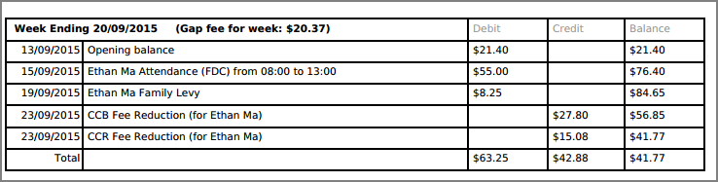

The child levy (listed as Family Levy in HubWorks), and the CCB and CCR rebates will appear once for each child in each weekly section, and will be a total amount for that week. The child levy is a charge and therefore listed as a debit, whilst the rebates appear as a credit as they reduce they amount you are required to pay. Any payment you make to your account will also be listed as a credit.

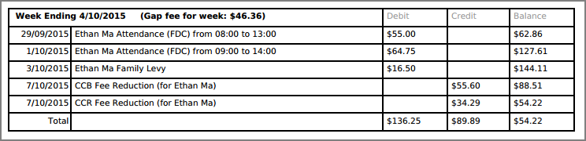

UNDERSTANDING THE CALCULATIONS
If you have any unpaid fees, your balance will appear in the first row of the first week of your invoice. In the example below this has been highlighted in blue.

The balance in the second week of your invoice is the balance of the first week plus the cost of care for the first day of care in week two. In the example below this has been highlighted in green. The balance of $96.77 equals the previous week’s balance of $41.77 plus $55 for the care provided on 22/09/2015.

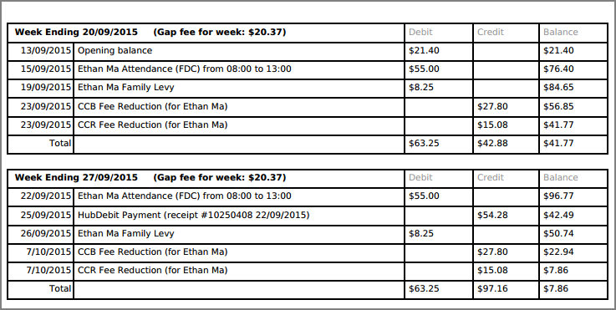
+
+
-
-
=
=
=
=
+
=

The Gap Fee, listed in brackets after the week ending date is the actual parent payment amount for that week. The parent payment is the total cost of care for that week plus the child levy, minus any CCB or CCR rebates.
In the example above, in week one the total charges equal $63.25 minus the total subsides which equal $42.88

Any payments you make to your account will appear with the receipt number and date of payment.

